[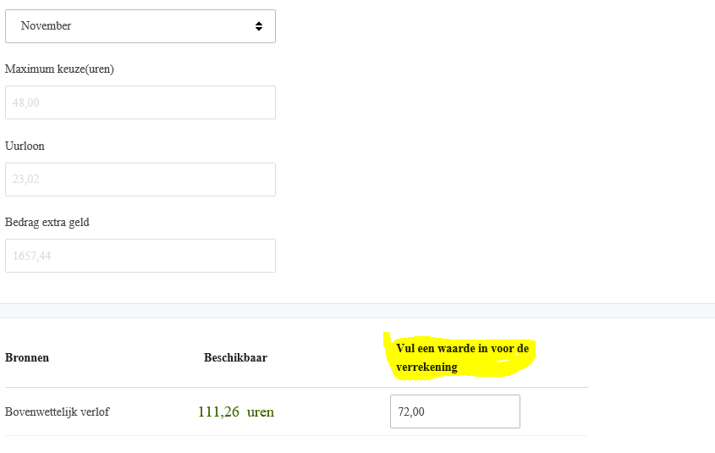](https://login.youforce.biz/FlexBenefits/home/makechoice/PRDR_EGM)